

DHOLE PATIL COLLEGE OF ENGINEERING WAGHOLI,PUNE-412207

A

**PROJECT REPORT ON**

**LIBRARY MANAGEMENT SYSTEM**

**SUBMITTED BY**

**Nikhil Birajadr Exam No: 72153951D**

**Pratik Ghadge Exam No: 72153971J**

**Sujit Deshmukh Exam No: 72153971J**

in partial fulfilment for the award of the degree

**OF**

**BACHELOR OF ENGINEERING IN**

**INFORMATION TECHNOLOGY AT**

PROJECTREPORTON

|  |  |  |
| --- | --- | --- |
|  |  |  |
|  |  |  |
|  |  |  |
|  |  |  |
|  |  |  |

inpartialfulfillmentfortheawardofthedegree

OF

BACHELOROF ENGINEERINGININFORMATION TECHNOLOGYAT

SavitribaiPhulePuneUniversity,Pune

UnderTheGuidanceofProf.

**DEPARTMENTOFINFORMATIONTECHNOLOGY2021-2022**



DHOLE PATIL COLLEGE OF ENGINEERING WAGHOLI,PUNE-412207

DEPARTMENTOFINFORMATIONTECHNOLOGY

CERTIFICATE

This is to certify that,

Nikhil Birajdar Exam No. 72153951D

Sujit Deshmukh Exam No. 72153971J

Pratik Ghadge Exam No. 72153982D

have successfully completed the Database Management system Mini Project “Library Management System” in the institute during the period from 2021 to 2022. The project report has been approved as it satisfies the academic requirements in respect to Project work prescribed by the said degree.

Date:-

Place:-DPCOE

Prof. Nehali Shinde Prof. Rahul Ghode

(Project Guide) (Head of Department)

(External Examiner) Dr. Nihar Walimbe

(Principal)

**Acknowledgement**

This is to acknowledge all those without whom this project would not have been reality. Firstly, I would wish to thank our teacher Prof. Nehali Shinde who gave his immense support, dedicated her time towards it and made us understand how to make this project. Without her guidance, the project would not have been complete.

**Table of Contents**

1. Abstract
2. Introduction
3. Project aims and objectives
4. Background of Project
5. Software Requirement Specification
6. General description
7. Problem statement
8. Software and Hardware Requirements
9. Software Tools Used
10. Project Implementation
11. Library Management System ER diagram
12. Library Management System Schema Diagram
13. Future Scope
14. Conclusion
15. References

**Abstract**

Library Management System is a system which maintains the information about the books present in the library, their authors, the members of library and all. This is very difficult to organize manually. Maintenance of all this information manually is a very complex task.

The Library Management has been designed to computerize and automate the operations performed over the information about the members, book issues and returns and all other operations. This computerization of library helps in many instances of its maintenances. It reduces the workload of management as most of the manual work done is reduced.

**Introduction**

The main aim of this project is to provide an easy to handle and automated library management system. This project also provides features and an interface for maintaining librarian’s records, student’s history of issues, and fines. The owner can easily update, delete and insert data in the database with this project.

**Project Aims and Objectives**

The aims and objectives are as follows:

* Every information of student , lecturer

and books.

* Can be able to add, update, delete, show or reset the data.
* Stores history of every student and book.

**Background of Project :**

Library Management System is an application which refers to library systems which are generally small or medium in size. It is used by librarian to manage the library using a computerized system.

Books and student maintenance modules are also included in this system which would keep track of the students using the library and also a detailed description about the books a library contains. With this computerized system there will be no loss of book record or member record which generally happens when a non computerized system is used.

**Software Requirement Specification :**

General Description :

Library Management System is a computerized system which helps user (librarian) to manage the library daily activity in electronic format. It reduces the risk of paper work such as file lost, file damaged and time consuming. It can help user to manage record more effectively and timesaving.

Problem Statement :

* File lost :

When computerized system is not implemented file is always lost because of human environment . Sometimes due to some human error there may be a loss of records.

* File damaged when a computerized system is not there file is always lost due to some accident like spilling of water by some member on file accidentally.

Besides some natural disaster like floods or fires may also damage the files.

* Difficult to search record When there is no computerized system there is always a difficulty in searching of records if the records are large in number.

**Software and Hardware requirements :**

Software Requirements :

Operating system- Windows 11 is used as the operating system as it is stable and supports more features and is more user friendly .

Database MYSQL-MYSQL is used as database as it easy to maintain and retrieve records by simple queries which are in English language which are easy to understand and easy to write.

Development tools and Programming language- HTML is used to write the whole code.

Hardware Requirements :

AMD Ryzen 5 is used as a processor because it is fast than other processors an provide reliable and stable and we can run our pc for longtime. By using this processor we can keep on developing our project without any worries.

**Software Tools Used**

The whole Project is divided in two parts the front end and the back end.

Front End :

The front end id design by using Python.

**Python :**

The Python language type is a high-level, dynamically typed one that is among the most popular general-purpose programming languages. It is among the world’s [fastest-growing programming languages](https://www.zibtek.com/blog/the-incredible-growth-of-python/) and is used by software engineers, mathematicians, data analysts, scientists, network engineers, students, and accountants.

Back End :

**MySQL :**

MySQL is a relational database management system based on the Structured Query Language, which is the popular language for accessing and managing the records in the database. MySQL is open-source and free software under the GNU license. It is supported by **Oracle Company**.

Query for connection between MySQL and Python in command prompt:

C:\Users\deshm>pip install mysql-connector-python

**Project Implementation**

Screenshot of homepage

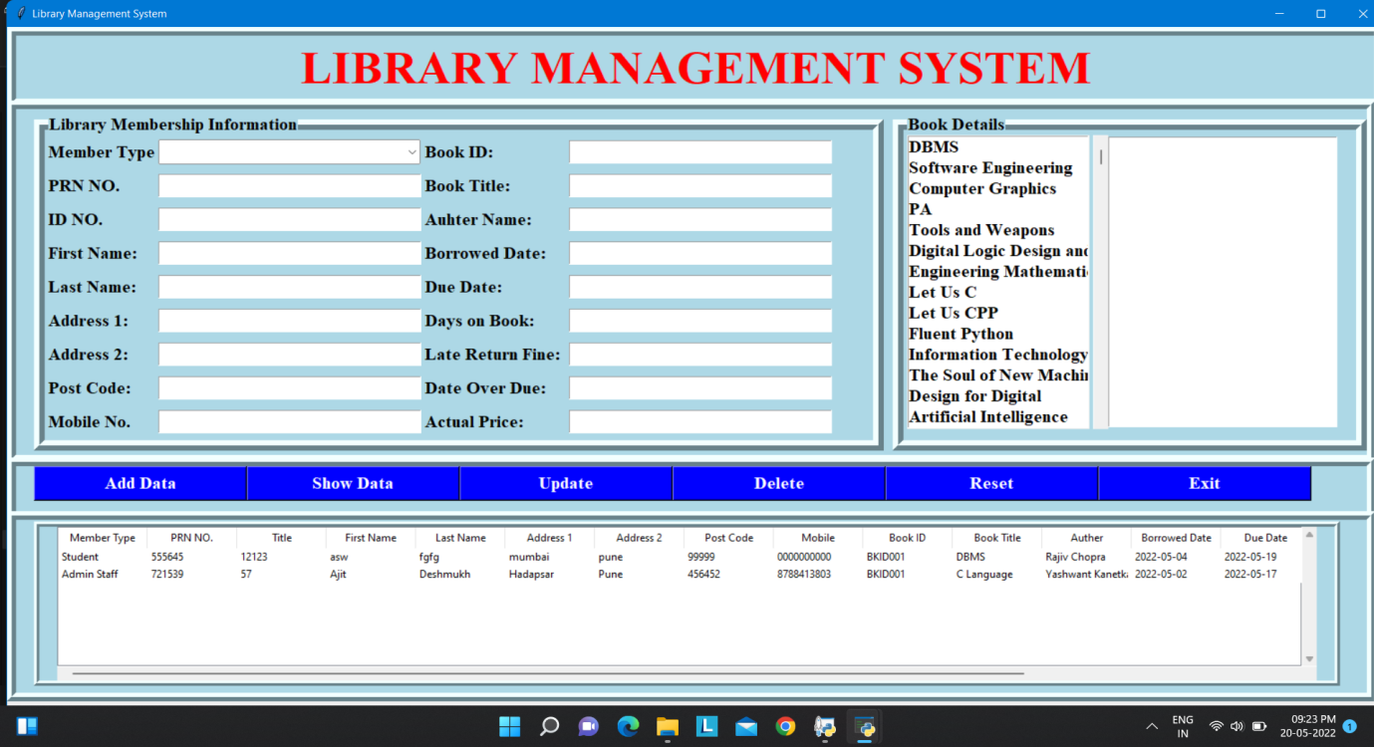

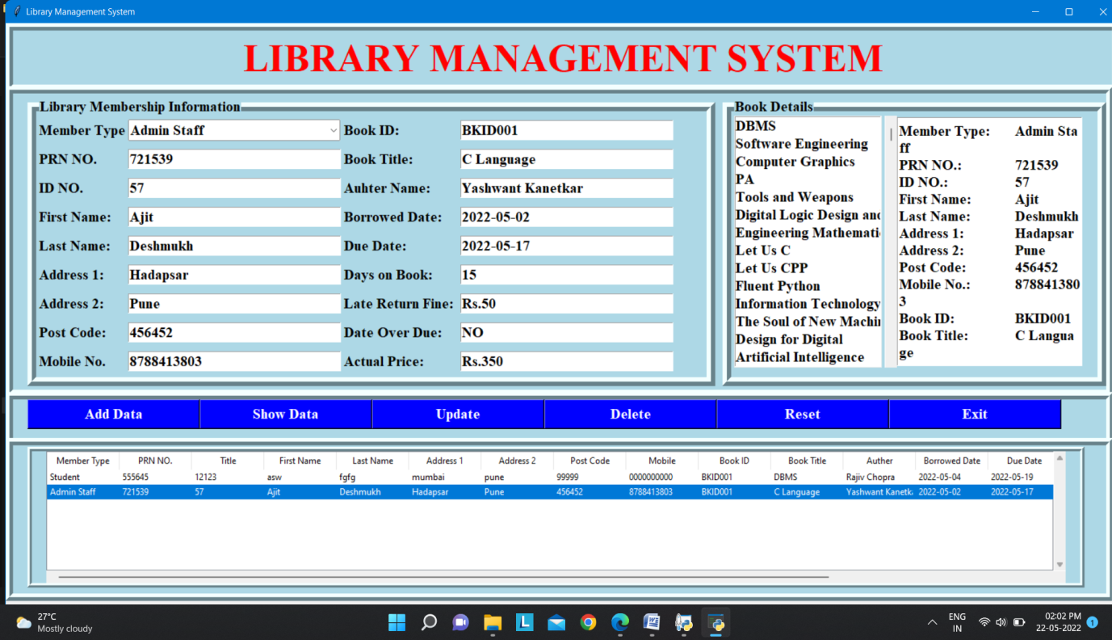Screenshot after data entry

Screenshot of MySQL Database:

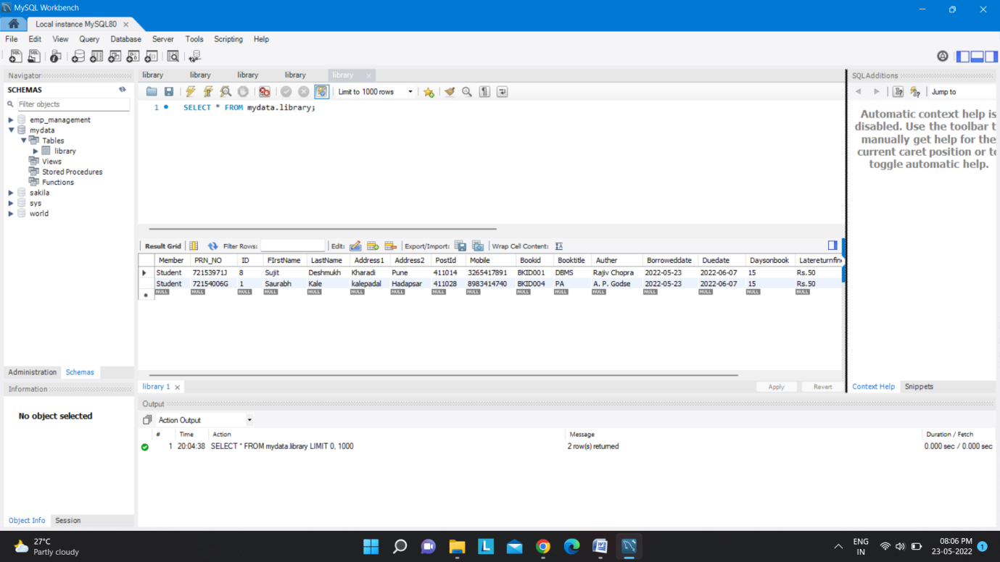

Screenshot of MySQL table :

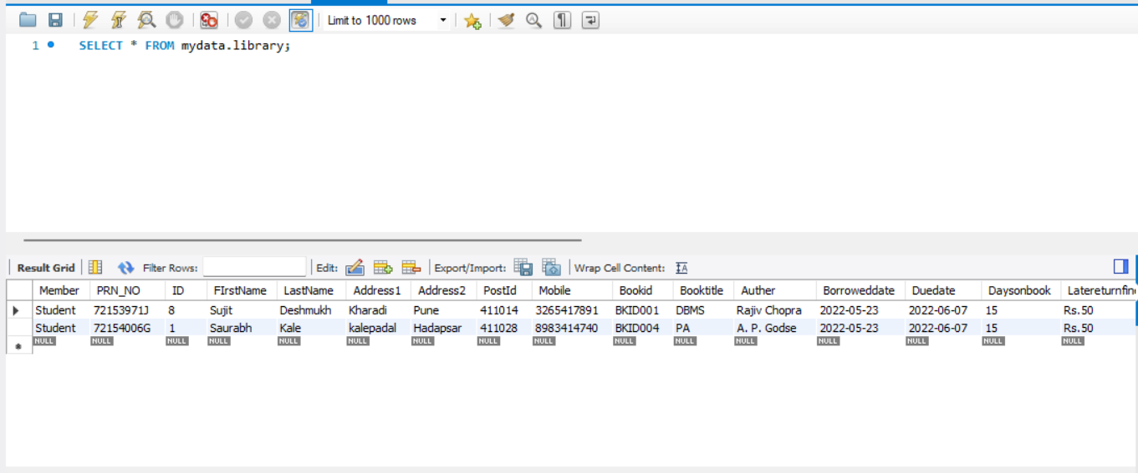

**Library Management System ER diagram**

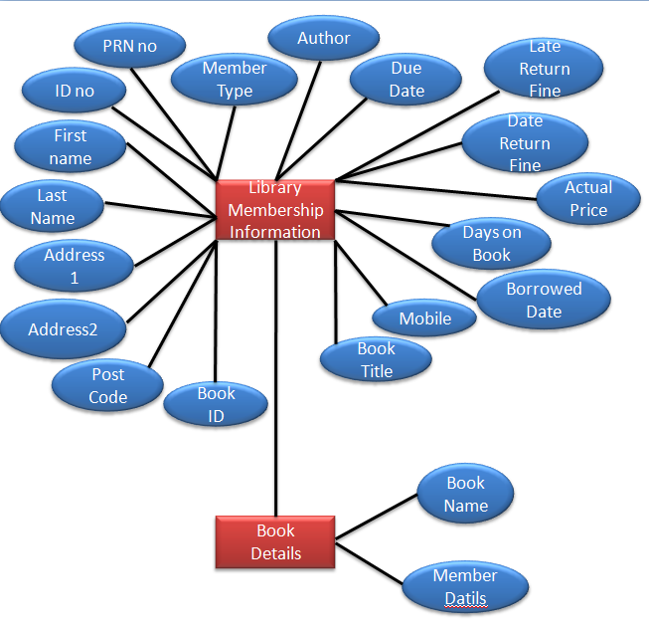

**Library Management System Schema Diagram**

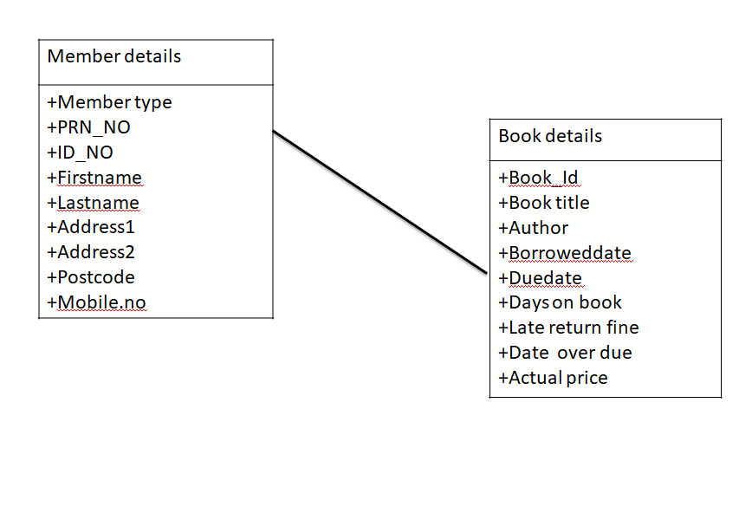

**Future Scope :**

There is a future scope of this facility that many more features such as online lectures video tutorials can be added by teachers as well as online assignments submission facility , a feature Of group chat where students can discuss various issues of engineering can be added to this project thus making it more interactive more user friendly and project which fulfills each users need in the best way possible.

**Conclusion :**

This project provides a computerized version of library management system which will benefit the students as well as the staff of the library.

This project has facility to add , update , reset, delete the data written in information table. This project also has facility that information of book like author, Book title, Book price are automatically fill by clicking on the book which student, lecturer wants. It also saves Borrowed date and return date in member information.

**References**

<https://www.w3schools.com/python/python_intro.asp>

<https://github.com/Sujitdesmukh/Library_Management_System>

<https://www.w3schools.com/python/python_mysql_getstarted.asp>